**Software Developement life Cycle**

It is a Process used by Software Industies.to design ,developed and test and finally to deliver a high-quality Application to the customer.

let's i am working at example.com ,at example.com we are building and delivering the E-Commerce application ,in that they need to launch a kids session

In that we have different phases

**1)planning**

business Analyst and product owner or senior menbers will get the inputs/requirements from Customers

so this is the most important phase in SDLC

**2)Defining**

you clearly define the requirements interms of Document i.e Software requirement Specification Document -they will maintain the all the requirements of the application in this Document

**3)Designing**

Designing phase is very Critical phase in this you will do HLD and LLD.

Let's say you have a Architect or you have a Team Leader or a Senior resource ,what they do is they will write a High level Design

on the HLD ,you will be talking about the overall

like System has to be scalable or whenever there is a requirement ,there will be more load for the kids session during festival season

so you have to build your application scalable ,when it require

for that these database is require and this many of replication sets are require

LLD: in the LLD the senior menbers of organization will design the systems in such a way they would mention

i want to some database and to will such response

**4)implementation and developing**

developers are writting/Devloping the code then they are checkin their code in centalized repository.

**5)building** :

After developers checkin the code into the repository we are trying to checkout the code and build the code

**6)Testing**

then QA team will test the code

**7)deploying**

then finally deploying

**8)Monitoring** :

then monitoring the application

**What is the Waterfall model?-**Waterfall methodology best suits projects with clear, fixed, and documented requirements, well-defined technical tools, architectures, and infrastructures, and a short life cycle.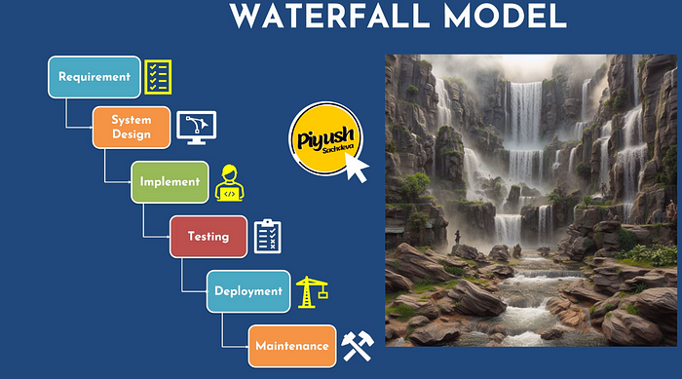

**Agile methodologies** have introduced iterative development, which emphasizes collaboration and adaptability. This approach allows teams to continuously improve their work by breaking down projects into smaller, manageable pieces and incorporating feedback.

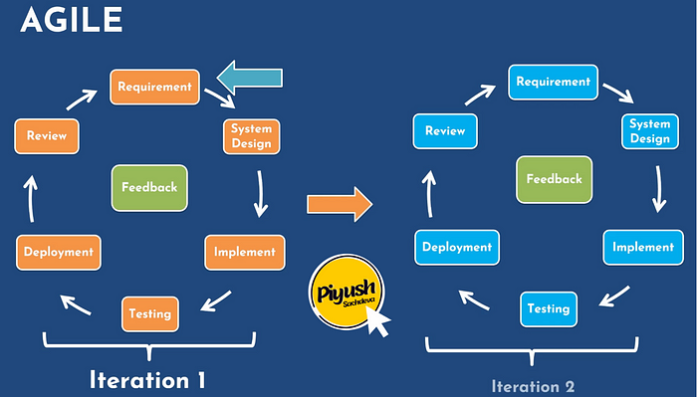**DevOps** expands on integrating development and operations, emphasizing automation, monitoring, and continuous feedback.

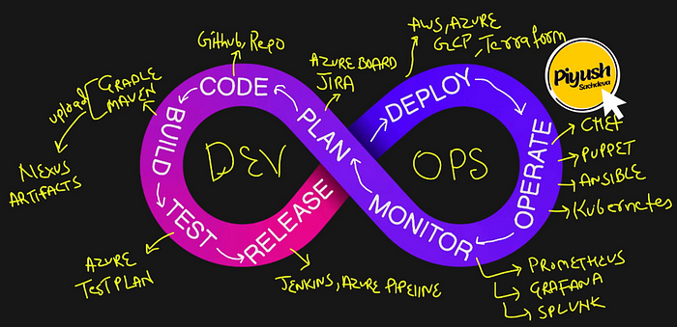**It includes various phases:**

**Continuous integration (CI)** automates code integration from multiple contributors into a single project. It includes Build, test, security scans, etc.

**Continuous deployment (CD)** is an automated software release process that uses rigorous testing to validate changes before autonomous deployment to production. It doesn't require manual intervention from the code commit until it's deployed into production.

**Continuous delivery (CD)** refers to the automated process of delivering completed code to testing and development environments, providing a consistent and efficient way to deploy code. A manual intervention is required to deploy the code to production.

**Continuous monitoring**is an automated and ongoing process for evaluating the performance and security of an organization's systems and processes.

**What is DevOps ?**

DevOps is basically a culture that improves the organizational ability to deliver their application.

and it is not only about delivery

1)improves the delivery by ensuring proper Automation

2)and Continuous Testing

3)Continuous Quality that we have maintained for the application

4)Continuous monitoring

by involving all of these things we improves the application delivery for the organization.

**Why DevOps**?

for example : developers are writing the code for application

whether it is a static website applicationor android applicationweb application

the end goal is deliver that application into a specific platform to the customer.

in between developer writing the code to the customer who is receiving the application there is a lot of processes

need to test that code in server for that system administrators will create the servers

and after build and release engineers will deploy and to run that application need to install the application servers

server admin will install the app servers

so there will be lot of team members are involved and lot of time will be takes place to deliver the application bcz we are doing the all of things manually

To automate the entire process and improves the application delivery DevOps has involved or emerged into the agile methodology in SDLC